Chocolate Terrine

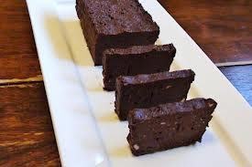
Golden raisins 1/2 cup
Dried cherries 1/2 cup
Craisins 1/2 cup
Semi sweet chocolate 6 oz.
Sugar 1/2 cup
Water 4 Tbs
Cocoa Powder 1 cup
Unsalted Butter, softened 1 1/2 sticks
Dark Rum 1 Tbs
Eggs, beaten 1 each
Egg Yolks beaten 2 each

Method
1. In a double boiler melt the chocolate.
2. Place the sugar and water in a saucepan until it is dissolved and the syrup is clear.
3. Place the cocoa powder and softened butter in a bowl and stir until smooth. Stir in
the sugar syrup, and then the melted chocolate. Add the dark rum and stir.
4. Add the whole egg and egg yolk into the mixture and mix well.
5. Fold in the dried fruits and immediately press the mixture into a 5x8 inch mold or loaf pan. (First rub the pan with butter which will keep the mix from sticking to the pan)
6. Tap the pan’s bottom on a flat surface to remove air bubbles and refrigerate overnight.
7. To unmold, run a knife around the sides of the terrine. Dip the mold into hot water
then invert onto a serving platter.
8. Garnish with fresh fruits, cocoa powder and confectionary sugar

